NA Miata 1.6 (4.3 gear ratio) to 1.8 (3.6 gear ratio) Differential Swap w/ 1.8 6 Speed Transmission
- 1.8 Differential (Torsen 2 LSD – 3.6 Ring & Pinion Installed)
- 1.8 Axles (1 piece vs 1.6 Axle 2 piece)
- 1.8 Drive Shaft (shorter length than a 1.6 because Diff is longer)

Wheels | Stock NA | Update NA
Tire Width (mm) | 185 | 205
Rim Inches | 14 | 15
Tire Profile | 60 | 50
Tire Diameter (in) | 22.7 | 23.1
Tire Circumference (in) | 71.31415324 | 72.5707903

 | Import NB 6 Speed | Stock NB 6 Speed | Stock 1.6 NA 5 Speed
Diff Ratio | 3.636 | 3.909 | 4.300

NA 1.6 | 5 Speed | 4.3 | 1000 | 2000 | 3000 | 4000 | 5000 | 6000 | 7000 | 7200
1st | 3.136 | 13.4848 | 5.0 | 9.9 | 14.9 | 19.9 | 24.9 | 29.8 | 34.8 | 35.8
2nd | 1.888 | 8.1184 | 8.3 | 16.7 | 25.0 | 33.3 | 41.7 | 50.0 | 58.3 | 60.0
3rd | 1.330 | 5.719 | 11.8 | 23.6 | 35.4 | 47.2 | 59.0 | 70.8 | 82.6 | 85.0
4th | 1.000 | 4.3 | 15.7 | 31.5 | 47.2 | 62.9 | 78.7 | 94.4 | 110.1 | 113.3
5th | 0.814 | 3.5002 | 19.3 | 38.0 | 58.0 | 77.3 | 96.6 | 116.0 | 135.3 | 139.2
NA 1.6/1.8 | 6 Speed | 4.3 | 1000 | 2000 | 3000 | 4000 | 5000 | 6000 | 7000 | 7200
1st | 3.760 | 16.168 | 4.2 | 8.4 | 12.6 | 16.7 | 20.9 | 25.1 | 29.3 | 30.1
2nd | 2.269 | 9.7567 | 6.9 | 13.9 | 20.8 | 27.7 | 34.7 | 41.6 | 48.5 | 49.9
3rd | 1.646 | 7.0778 | 9.6 | 19.1 | 28.7 | 38.2 | 47.8 | 57.3 | 66.9 | 68.8
4th | 1.257 | 5.4051 | 12.5 | 25.0 | 37.5 | 50.1 | 62.6 | 75.1 | 87.6 | 90.1
5th | 1.000 | 4.3 | 15.7 | 31.5 | 47.2 | 62.9 | 78.7 | 94.4 | 110.1 | 113.3
6th | 0.843 | 3.6249 | 18.7 | 37.3 | 56.0 | 74.7 | 93.3 | 112.0 | 130.6 | 134.4
Setup w/ 3.6 | 6 Speed | 3.636 | 1000 | 2000 | 3000 | 4000 | 5000 | 6000 | 7000 | 7200
1st | 3.760 | 13.67136 | 4.9 | 9.9 | 14.8 | 19.8 | 24.7 | 29.7 | 34.6 | 35.6
2nd | 2.269 | 8.250084 | 8.2 | 16.4 | 24.6 | 32.8 | 41.0 | 49.2 | 57.4 | 59.0
3rd | 1.646 | 5.984856 | 11.3 | 22.6 | 33.9 | 45.2 | 56.5 | 67.8 | 79.1 | 81.4
4th | 1.257 | 4.570452 | 14.8 | 29.6 | 44.4 | 59.2 | 74.0 | 88.8 | 103.6 | 106.6
5th | 1.000 | 3.636 | 18.6 | 37.2 | 55.8 | 74.4 | 93.0 | 111.6 | 130.2 | 134.0
6th | 0.843 | 3.065148 | 22.1 | 44.1 | 66.2 | 88.3 | 110.4 | 132.4 | 154.5 | 158.9

Reference Pictures:

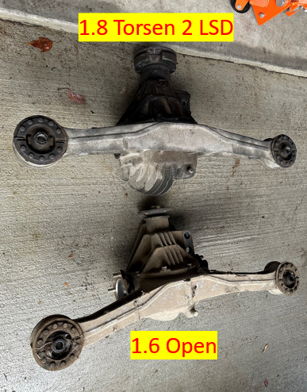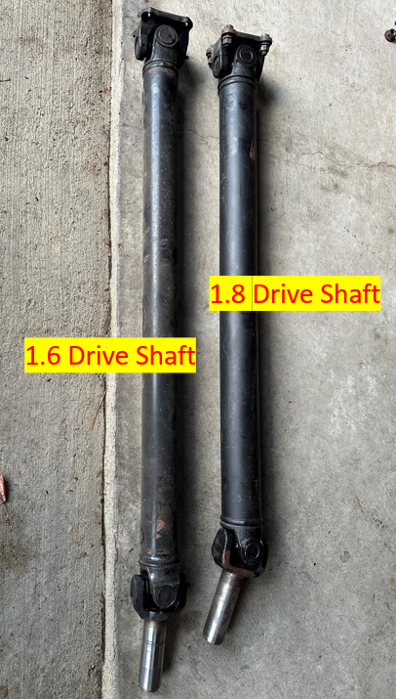
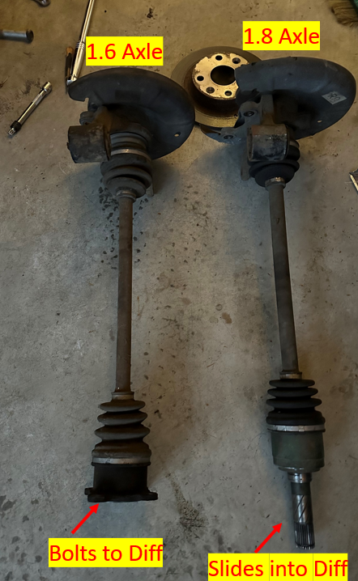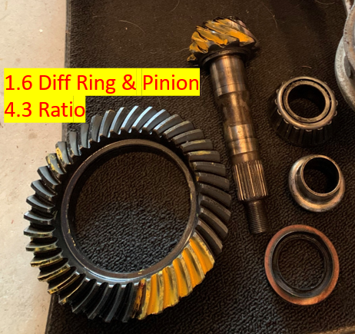
Tools needed:
Socket Wrench Set – 10mm, 12mm, 14mm, 17mm, 19mm, 21mm, 23mm, 24mm
Wrench (Ratchet is nice to have)– 14mm. 17mm
Allen Wrench – 4mm
Torque Wrench
Pry Bar
Fluid pump
Floor Jack/Jack Stands or Lift
Rubber Mallet (is nice to have)
Eye Protection (highly recommended)
A friend (I wish I had somebody to help me)

Purchase items:
1 qt - Redline 75W90 GL-5 Full Synthetic
2 qt - Ford Genuine Fluid XT-M5-QS Full Synthetic Manual Transmission Fluid
18mm crush washer

Removal Steps:

Wheel Removal
- 21mm – Lug Nuts (19mm Custom)

Driveshaft Removal
- Transmission fluid drain
  - If you don’t drain, you will leak tranny fluid. Be ready with a drain pan under the location where Driveshaft interfaces Transmission
  - 1.8 6 Speed Transmission
    - There’s a bolt that looks like a drain bolt on the passenger side, do not unscrew this or you will be screwed!
    - 24mm – Fill Bolt (Driver’s Side next to exhaust)
    - 24mm – Drain Bolt (Bottom Driver’s Side)
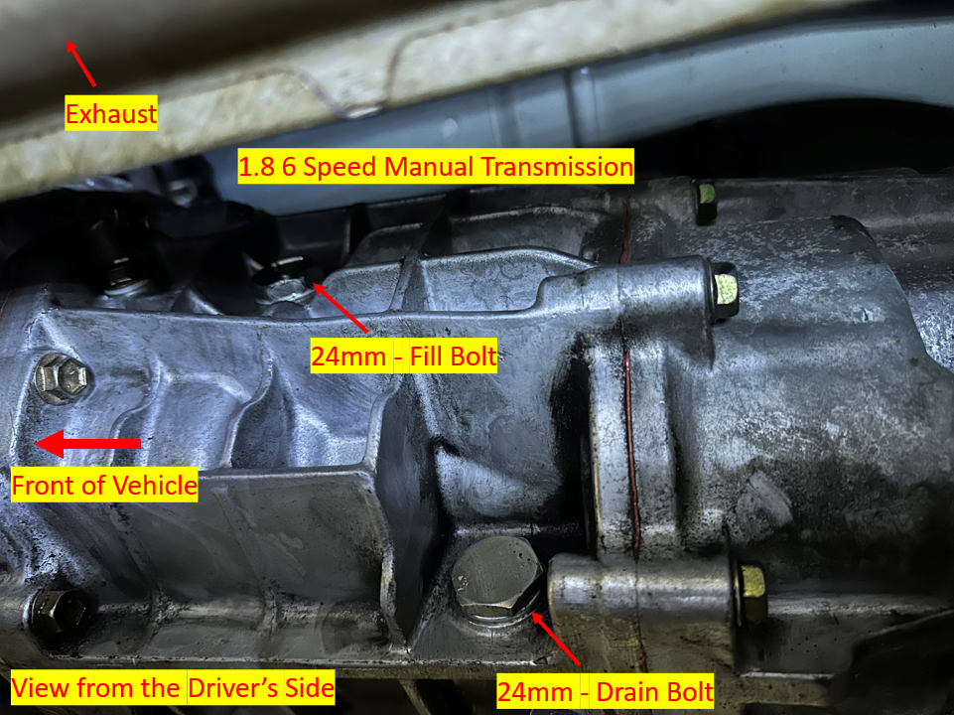

  - 1.6 or 1.8 5 Speed Transmission
    - 14mm Square – Fill Bolt (Crescent wrench or 9/16 Socket will work)
    - 24mm – Drain Bolt
- 14mm – 4 Differential shoulder bolts, washer, and nuts (note: 1.6 set is shorter than the 1.8)

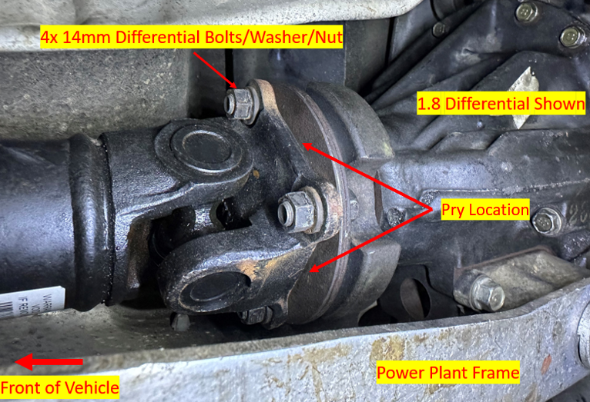

- Pry the Driveshaft out
- Transmission fluid will leak (this is a good time to do a flush, drain tranny fluid)

Axle Removal (Reference Only, if you’re reusing your Axles – I didn’t do this)
- 29mm – Large Flange Nut
- Pins and hammer to unlock Large Flange Nut

1.6 Rear Axle Removal
- Brake Caliper Removal
  - 14mm Bolts – Two (top and bottom)
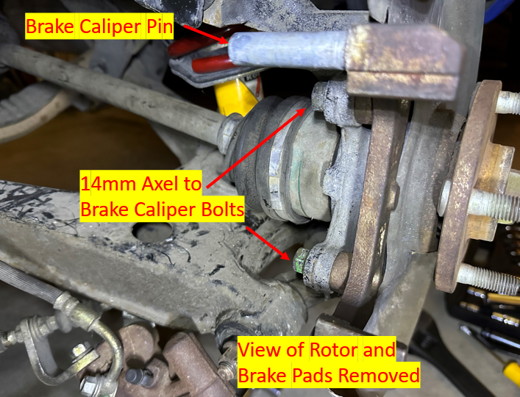
  - 14mm Screw Cap
    - 4mm Allen to loosen calipers
  - 10mm Brake Caliper Threaded Bolt Pin (this is so you can remove the brake pad kit)
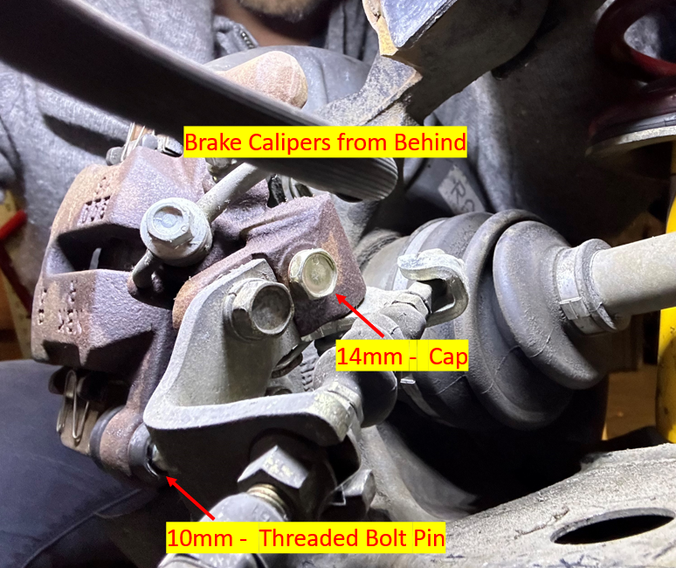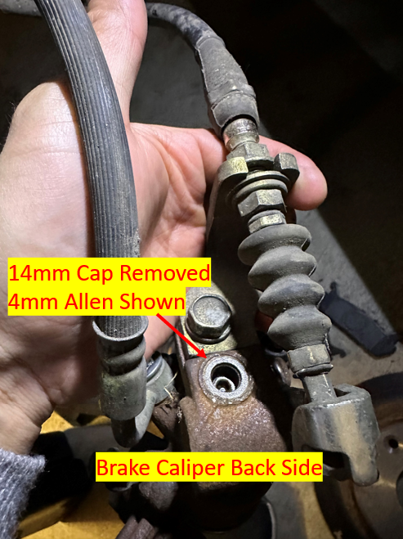
- 17mm Top Control Arm Nut / 17mm Top Control Arm Bolt
- 17mm Bottom Control Arm Nut / 19mm Control Arm Bolt (Long Bolt)
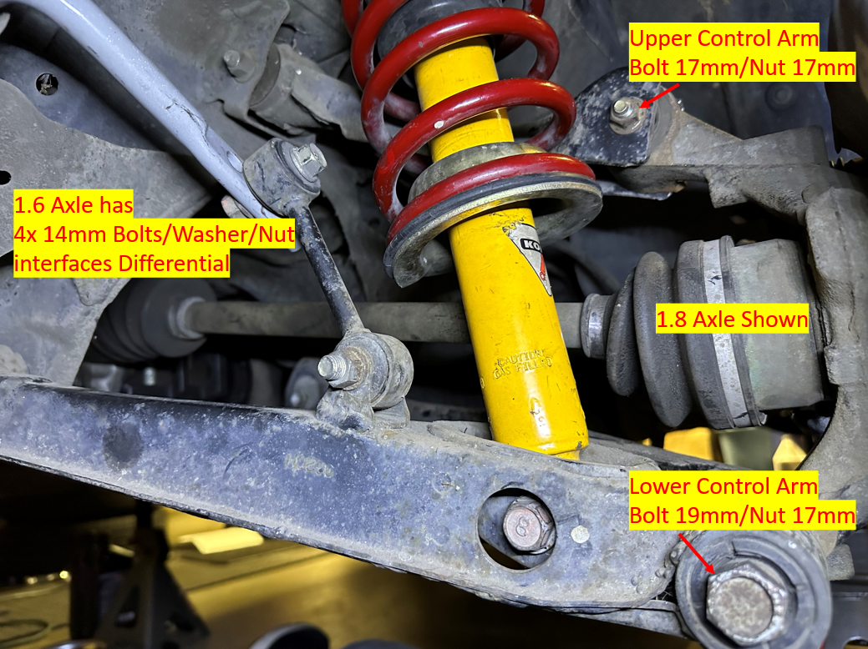
- 14mm – 4 Axle to Diff nuts / washers (note: 1.6 is a 2 piece axle, 1.8 is a 1 piece axle)
  - You won’t need these once you install the 1.8

1.6 Diff removal
- Diff Fluid drain
  - 23mm – Fill Bolt
  - 24mm – Drain Bolt

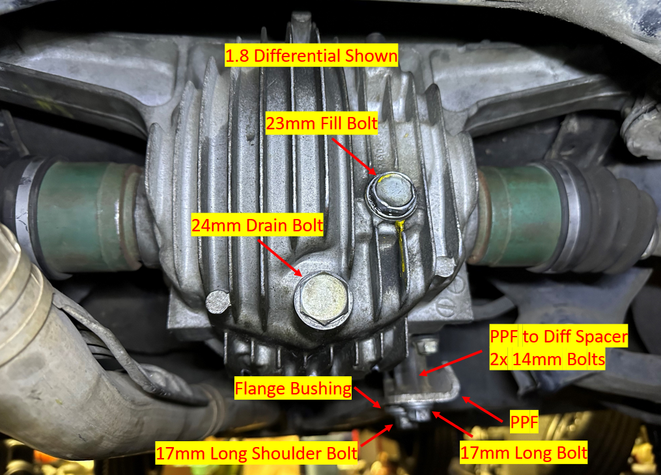

- Exhaust Removal (I took all the exhaust hangers off and just angled it down slightly out of the way but supported it with another lift)

- PPF - Power Plant Frame (There’s total of 5 fasteners but only need to remove 2 holding the Diff for Diff Swap)
  - 17mm – Long Bolt
  - 17mm – Shoulder Bolt
    - Need to pry the flange bushing out
  - Remove PPF to Differential Spacer
    - 14mm – 2 bolts that hold the spacer to the diff
  - Remove spline nut (I didn’t have to do this, check your Miata model)

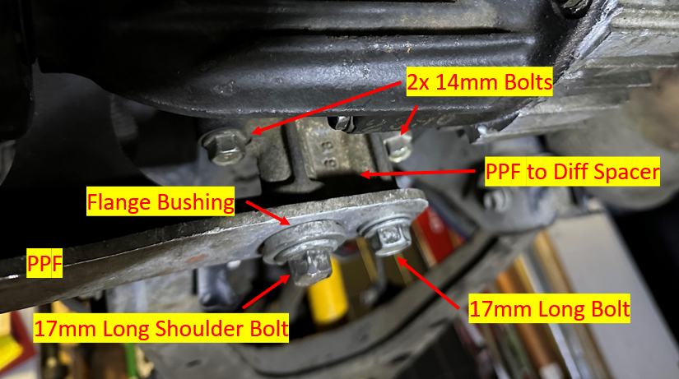

- Diff Mount Removal
  - 12mm Diff mount bolts – 12mm – 2 on each side (right and left)
  - Get a floor jack to support the weight of the Diff
  - 17mm Diff nut

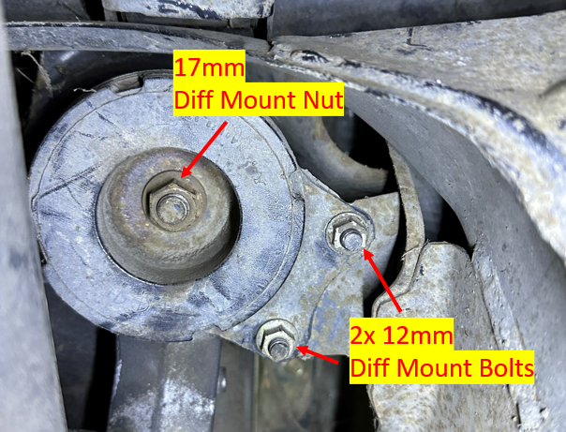

- Remove Diff
  - Diff is now loose
  - Slide the diff out of the PPF and remove Diff
  - PPF and exhaust are connected so you will need to support if you didn’t take the exhaust off

Installation Steps:

1.8 Diff Install
- Raise the Diff (this was extremely difficult doing this alone)
  - Install Diff mounts
    - 12mm – 2 side bolts (Right & Left) – Torque 18-22ft/lbs (20ft/lbs)
    - 17mm – Diff nut – Torque 69-75ft/lbs (73ft/lbs)
  - Bolt PPF – Torque 77-91ft/lbs (85ft/lbs)

1.8 Drive shaft Install
  - 14mm – 4 shoulder bolts, washer, nuts (use the 1.8 set) – Torque 20-22ft/lbs (21ft/lbs)
  - A friend would be very helpful here to save time. Have them put the transmission into gear so you can torque without the drive shaft rotating. Put the gear back into neutral to rotate and put it back into gear to torque the next bolt. Repeat until complete.

1.8 Axle Install
- Slide axle into Diff
  - Clean the axle end and grease the ends
  - Carefully slide the axle ends into the Diff
- Seat the Axle
  - The retaining ring makes it very difficult to slide the axles into place, I couldn’t do this by hand
  - Tips on the forums say to position the gap in the retaining ring either on top or down, I haven’t confirmed if this myself.
  - Place a wooden block over the axle nut and give it a strong whack (this is what I did solo)
  - If you have two people, you can have one person hold it into place while the other one give it a good push
  - You should feel it pop into place. You shouldn’t be able to see the metal part of the axle once it’s in place.
- Install Axles back into Control Arms
  - Lower Control Arm Long Bolt – 19mm/17mm Torque 47-54ft/lbs (51ft/lbs)
  - Upper Control Arm Short Bolt – 17mm Torque 34-49ft/lbs (42ft/lbs)
- Install Brake Calipers – 14mm Torque 25-29ft/lbs (27ft/lbs)
  - When I did this, my brake pads, clips, springs all came apart. Make sure you don’t lose the springs like I did.
  - 10mm Threaded Bolt Pin – Torque 16-22ft/lbs (18ft/lbs)
  - The 4mm Allen bolt is related to the parking brake. Make sure you read up on this.
    - Good reference: https://www.youtube.com/watch?v=N-1HjYya5xU
    - Release handbrake, tighten Allen until the rotors are locked to the point you can’t rotate by hand.
    - Rotate counter clockwise 1/3 turn (I read people do up to ¾ turn), you should now be able to rotate the rotors.
    - Pull handbrake and the rotors should lock up again. Check what works for you.
  - 14mm Plug Bolt – Torque 9-12ft/lbs (10ft/lbs)
Fill Diff Fluid (Redline 75W90 GL-5 Full Synthetic)
- Fill Nut – 23mm 29-40ft/lbs (35ft/lbs)
- Drain Plug – 24mm 29-40ft/lbs (35ft/lbs)

Fill Transmission fluid (Ford Genuine Fluid XT-M5-QS Full Synthetic Manual Transmission Fluid 2 quarts or 2 liters)
- 1.8 6 Speed Transmission
  - 24mm – Fill Bolt – Torque 29-43 ft/lbs (35ft/lbs)
  - 24mm – Drain Bolt – Torque 29-43 ft/lbs (35ft/lbs)
- 1.6 5 Speed Transmission
  - Fill Nut – Square 14mm (Crescent wrench or 9/16 Socket will work) – Torque 18-29 ft/lbs (24ft/lbs)
  - Drain Plug – 24mm – Torque 29-43ft/lbs (35ft/lbs)
    - 18mm Crush Washer

Wheel Lugs – Torque 66-86ft/lbs (78ft/lbs)

Speedometer Sensor for 3.63 gear ratio
- Once you have this all setup, depending on your configuration, you will most likely need to update your speedometer sensor. I went for a test drive using GPS and my speedometer was off quite a bit. Check what sensor you need before you purchase, this is just for reference.
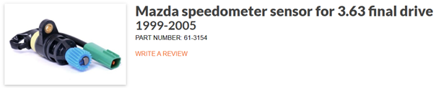
- Good reference on Install: Miata Speed Sensor - YouTube
